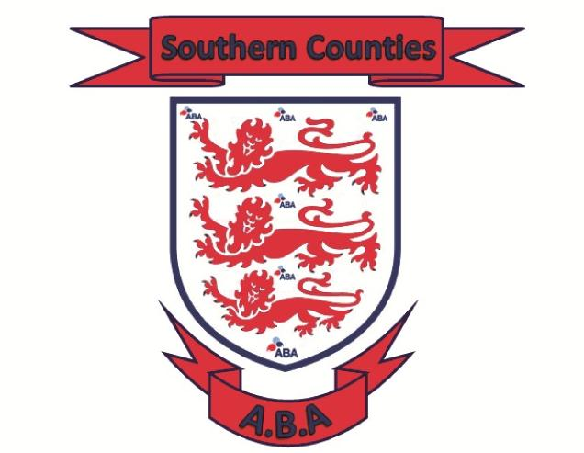 |  | Championship Committee Conference Call  Wednesday 12th April started at 8pm  Call hosted by Aaron  Minutes / Summary:  In attendance: Aaron P, Gary W (Sussex) Shaun A (Kent) Stuie G (Hants) Wayne P (Surrey) Leah J (Surrey)  The dates below have been agreed for:  England Boxing Youth & Youth Cadet Championships Male & Female 2024  Official Weigh In – Monday 15th January 2024  Draw (if required) 16th January 2024  Quarters & Semi Finals 20th January 2024 – Hampshire Hosting - Venue TBC  Any remaining box offs between 21st & 26th – Venue TBC  Association Finals – Saturday 27th January 2024 – Hampshire hosting, Venue TBC  Pre-Quarters – By 4th February 2024 – Southern Counties do not box in this round  Quarter Finals – 9th February 2024 – England Boxing run event – Venue and times TBC  Semis Finals – Saturday 10th February 2024 – England Boxing run event - Venue TBC  National Finals – Sunday 11th February 2024 – England Boxing run event - Venue TBC  Please contact your Championship Committee member for all Championship queries  Aaron Pritchard  Regional Secretary  07713 487008

Southern Counties ABA

Youth & Youth Cadet Championships
2024

Championship subcommittee
Shaun Akehurst (Kent)
Stuie Gill (Hampshire)
Gary White (Sussex)
Leah Jackson (Surrey)
Wayne Parrot (Surrey
Aaron Pritchard (Chair)

WEBSITE:
https://www.hantsandiowaba.co.uk/

EMAIL:
stherncounties@btinternet.com

