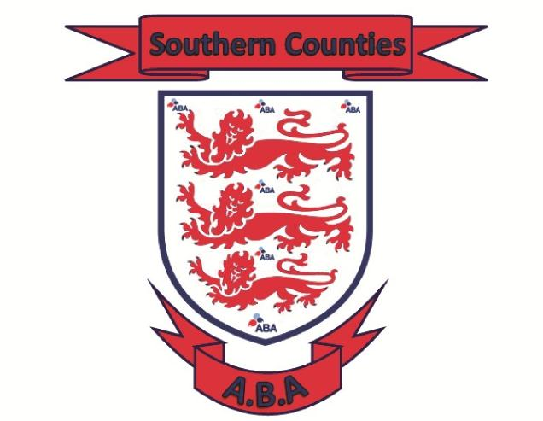 |  | Championship Committee Conference Call  Wednesday 12th April 2023 started at 8pm  Call hosted by Aaron  Minutes / Summary:  In attendance: Aaron P, Gary W (Sussex) Shaun A (Kent) Stuie G (Hampshire) Wayne Parrot (Surrey)  The dates below have been agreed for:  England Boxing Schools & Cadet Championships Male & Female 2024  Official Weigh In – Monday 25th March 2024  Divisional Box Off – Saturday 30th March 2024  Venue TBC  Inter County Round – Saturday 13th April 2023 – Hants hosts Surrey & Kent hosts Sussex  Venue’s TBC  Association Finals – Saturday 20th April 2024 – Surrey Hosting Venue TBC  Pre-Quarters – by 28th April 2024 – Home Counties hosts Southern Counties  Quarter Finals – by 5th May 2024 – Eastern Counties hosts Home Counties/Southern Counties – Venue and times TBC  Semis Finals – Saturday 11th May 2024 – England Boxing run event - Venue TBC  National Finals – Sunday 12th May 2024 – England Boxing run event – Venue TBC  Please contact your Championship Committee member for all Championship queries  Aaron Pritchard  Regional Secretary  07713 487008

Southern Counties ABA

School & Cadet Championships
2024

Championship subcommittee
Shaun Akehurst (Kent)
Stuie Gill (Hampshire)
Gary White (Sussex)
Leah Jackson (Surrey)
Wayne Parrot (Surrey
Aaron Pritchard (Chair)

WEBSITE:
https://www.hantsandiowaba.co.uk/

EMAIL:
stherncounties@btinternet.com

