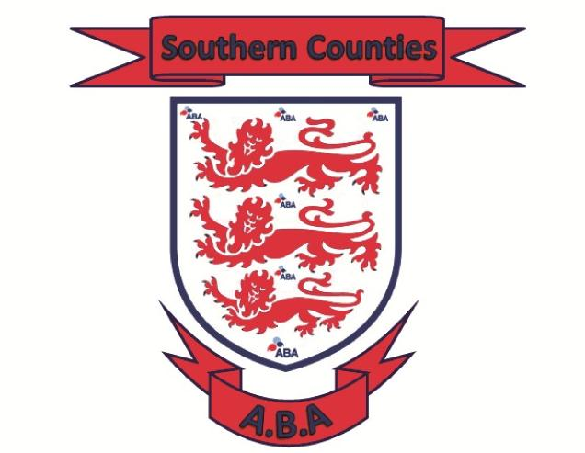 |  | Championship Committee Conference Call  Wednesday 12th April 2023 started at 8pm  Call hosted by Aaron  Minutes / Summary:  In attendance: Aaron P, Gary W (Sussex) Shaun A (Kent) Stuie G (Hampshire) Wayne Parrot (Surrey)  The dates below have been agreed for:  England Boxing National Amateur Championships Male & Female 2023  Official Weigh In – Monday 18th March 2024  Draw (if required) Tuesday 19th March 2024  Quarter & Semi Finals – Saturday 23rd March – Sussex hosting Venue TBC  Any remaining box offs between 24th – 29th March 2024  Venue TBC  Association Finals – Saturday 30th March 2024 – Sussex Hosting – Venue TBC  Pre-Quarters – 6th April 2024 – England Boxing run event  Venue TBC  Quarter Finals – Saturday 13th April 2024 – England Boxing run event - Venue TBC  Semis Finals – Sunday 14th April 2024 – England Boxing run event - Venue TBC  National Finals – Saturday 20th April 2024 – England Boxing run event - Venue TBC  Please contact your Championship Committee member for all Championship queries  Aaron Pritchard  Regional Secretary  07713 487008

Southern Counties ABA

National Amateur Championships
2024

Championship subcommittee
Shaun Akehurst (Kent)
Stuie Gill (Hampshire)
Gary White (Sussex)
Leah Jackson (Surrey)
Wayne Parrot (Surrey
Aaron Pritchard (Chair)

WEBSITE:
https://www.hantsandiowaba.co.uk/

EMAIL:
stherncounties@btinternet.com

